30 | 20 | 50 | 100 | Grade
Class:8

Name SUMMATIVE ASSESMENT-1 SET-A
Roll No: Total marks:20
______________________________________________________________________________________________
1 Write the following components of the open-shot interface. 1/2x10=5M
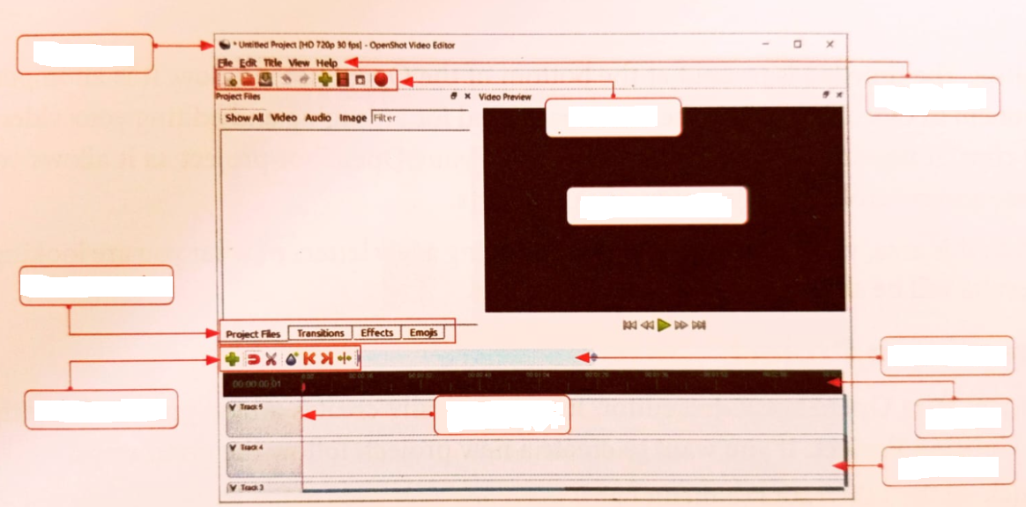
2.Fill in the blanks 1x5=5M
1.__________________ is the area where you can watch your video as you work on it.
2.__________________ is the workspace used for arranging and editing your video and audio.
3.A__________________ stores logically organised data.
4.In a relational database, data is stored in ________________________
5.The _________________ from screens can delay your sleep.
3. State whether the following statements are true or false. 1x5=5M
1.A cheerful photo online always means the person is feeling happy in real life. ( )
2.DBMS stands for Data Base making system. ( )
3.Null values are allowed in a primary key. ( )
4.OpenShot can only be used to edit audio files. ( )
5.Transitions can only be added to audio clips. ( )
4. select the correct option. 1x3=3M
1.Which of the following file types is used to save open shot project files?
a. .mp4 b. .osp c. .video
2.What happens when you press ctrl+N in open shot?
a. SaveFile b. Open File c. New Project
3.Which part of an application user see and interact with?
a. Frontend b. Backend c. Database
5.Answer any 1 question of the following. 2X1=2M
1. What is the purpose of a foreign key?
2.Write the query to see all the records of a table named students.

